**IDEATION PHASE**

**DEFINE THE PROBLEM STATEMENTS**

|  |  |
| --- | --- |
| **Date** | **18 September 2022** |
| **Team ID** | **PNT2022TMID13455** |
| **Project Name** | **IoT Based Smart Crop Protection System For Agricultrue** |
| **Maximum Marks** | **2 Marks** |

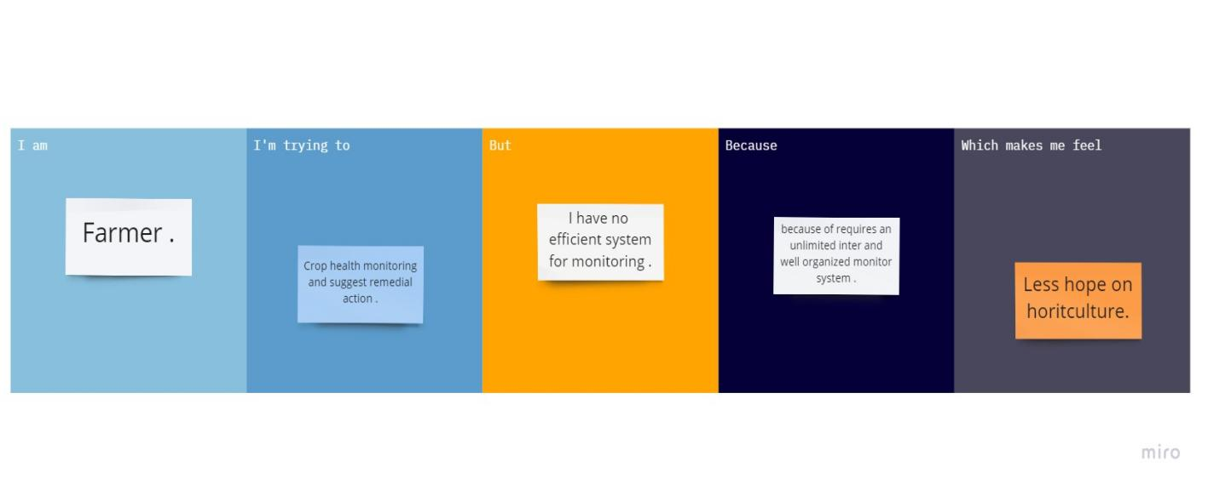

|  |  |  |  |  |  |
| --- | --- | --- | --- | --- | --- |
| **Problem Statement (PS)** | **I am (Customer)** | **I am trying to** | **But** | **Because** | **Which makes me feel** |
| PS-1 | Farmer | Monitoring the growing condition | It involves risk on related equipment and understand the use of technology | Requires more knowledge and skills | Irritated |
| PS-2 | Farmer | Smart and precision irrigation | Climates changes to increased maintenance of channels | Purchasing and installing costs high | Suitable for mass crop protection |